VILLAGE OF MONROEVILLE
PRST STD
U.S. POSTAGE PAID
NORWALK, OH
PERMIT NO 104
21 N MAIN ST
PO BOX 156
MONROEVILLE, OH 44847

ADDRESS SERVICE REQUESTED

The Administrative
Offices will be closed on the
following holidays…

May 29th – Memorial Day
June 19th – Juneteenth Day
July 4th – Independence Day
September 5th – Labor Day
October 9th – Columbus Day

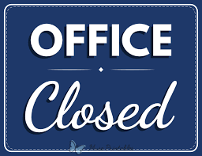

MONROEVILLE
COMMUNITY NEWSLETTER
SPRING 2023

Hello Friends and Neighbors,

A lot has happened since our last newsletter was published this past fall. Let me catch you up on some of the excitement.

On September 8th we celebrated a dream coming to fruition when we hosted the official Open House and ribbon cutting of our Monroeville Municipal Complex. (Because of COVID and the restrictions that surrounded it, we were unable to have such a celebration when we opened in September 2020.) Community members and dignitaries alike, filled the parking lot as we assembled for the ceremony, which was followed by building tours, a picture presentation and refreshments. It was a special day! We are very proud of our building and the energy that continues to “build “downtown. Many years of planning, saving and fiscal responsibility got us to the place where this beautiful building could come to be WITHOUT having to go to the taxpayers for additional taxes, but even more impressive is the fact that it was completed well under the projected budget. Continued downtown beautification will begin to be noticed as the weather starts to improve this spring.

As long as I am talking about downtown, Council and Village administration continue to work with designers/engineers to determine how downtown sidewalks can be improved. Unfortunately, it is not as easy as simply “fixing the sidewalks.” There are many “below-the-surface” issues (like abandoned coal chutes from Monroeville's earliest days) that need attention and to be factored into the equation in order to properly replace the sidewalks. We will continue to work on this issue.

This winter, as part of Monroeville's Christmas in the Park, we introduced the Mayor's inaugural Golf Cart Parade. This was a lot of fun and seemed to be enjoyed by all in attendance. The decorated carts were quite festive and prizes were given for the top three placers. (You will find pictures of the event in this newsletter.) Before we (Santa and I) lit the Christmas tree, a joint choir from both of our schools, sang beautiful carols. After a brief hiatus, Trinity Lutheran Church held their Live Nativity, as well. It is always nice when the community comes together to celebrate.

As always, I appreciate our employees who work together to make our village run smoothly. Last spring, I listed some employees who had milestone anniversaries working with us. Many of the employees were recognized for having 10, 20, and 30+ years of service to our community. As of this spring, we will have 2 officers celebrating five years with our police department. Thank you to Josh Querin and Kyle Sheehan for faithfully serving our village and the police department! I would also like to welcome the employees who have joined us in the last year: Trask Ott and Jonah Mersereau. Please take a moment to thank ALL of our employees and welcome our newest faces! We are lucky to have such a talented work force!

Lastly, a few weeks ago, Councilman Bob Whitacre, Tom Gray, our Village Administrator and I, had the privilege of meeting with students from St. Joseph's School. During our visit, we each were able to talk about our job within the village. Afterwards, I challenged those students to help build up our community. “Be kind. Help each other. Help take care of our resources. Treat others and property with respect. Do the right thing, even when you think nobody is watching.” As I reflected on my time with those students. I couldn't help but think we could ALL use those reminders. So once again, here is my challenge to everyone reading this: Strive to be the good that others need in their life. Continue to build our reputation of Monroeville being the “Little Village with a Gigantic Heart!” I continue to be so very proud of our village and everything that it represents!

Yours in Service,

Mayor Melissa Fries-Seip

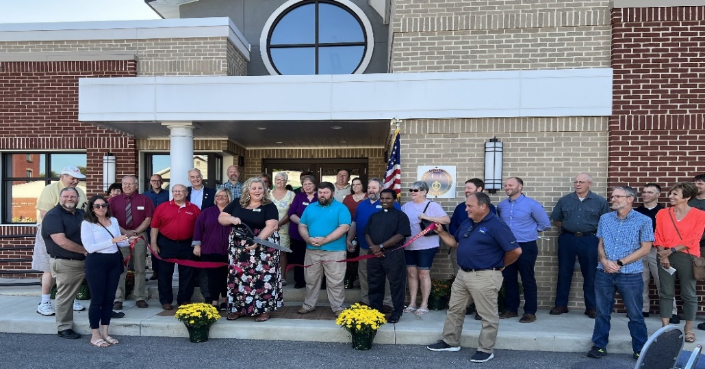

PICTURED LEFT: RIBBON CUTTING CEREMONY FOR OUR MONROEVILLE MUNICIPAL COMPLEX.

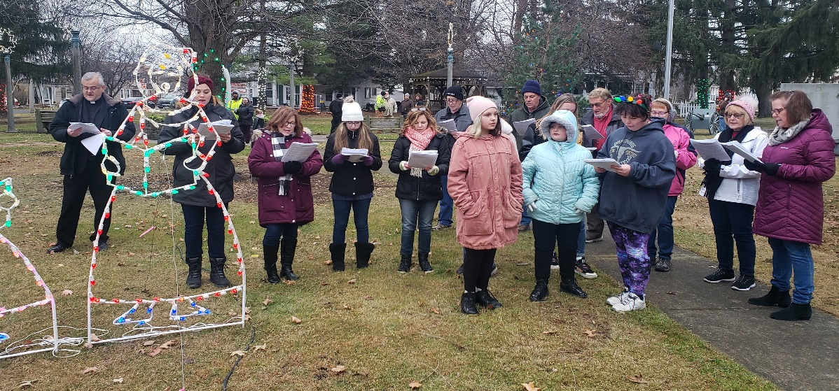

PICTURED ABOVE: CHRISTMAS CAROLERS AT OUR VILLAGE CHRISTMAS-IN-THE-PARK.

PICTURED BELOW: THE MAYOR’S INAUGURAL DECORATED GOLF CART PARADE.

VILLAGE OF MONROEIVLLE
21 N MAIN ST PO BOX 156
419-465-2922 / 419-465-4443

BONNIE BECK, FISCAL OFFICER MELISSA FRIES-SEIP, MAYOR TOM GRAY, VILLAGE ADMINISTRATOR
fiscalofficer@monroevilleohio.com mayor@monroevilleohio.com villageadm@monroevilleohio.com

FLUSHING NO-NO’s:

Please be aware that certain things are NOT flushable!!!!!!

Wipes and Facial Tissues
Band-Aids
Napkins and Paper Towels
Cotton Balls and Swabs
Dental Floss
Hair
Feminine Sanitary Products
Eggshells and Coffee Grounds
Grease, Oil and Fat
Kitty Litter
Medication

Just to name a few!

According to the Village’s Rules & Regulations, the customer owns the sewer lateral all the way to the main including the connection to the main. If our sewer main is running and yours is not, you are the responsible party, you will need to make arrangements to have your lateral taken care of at your expense, if it is determined that you have put anything in the sewer that creates an issue for other people also tied into our Sanitary Sewer System, you will be financially responsible for that as well.

The Wastewater Dept. will continue its ongoing efforts to maintain, clean & inspect our sanitary sewer mains.

WATER MAIN IMPROVEMENTS

Looking for a CAREER? The Water & Wastewater Department currently has an opening that needs to be filled sooner than later. This position will be advertised on the Village’s website & in local newspapers.

The EPA is mandating public water systems to complete a lead service line inventory by October of 2024. To meet this mandate the Village needs to verify the service line material on both the Village and privately owned side (normally from meter or curb stop to the connection in the basement). In order to accomplish this, we will need to gain access to most basements. You can call the Water Dept. at 419-465-4182 to set up a day and time to have this done. The goal is to eliminate all lead from the drinking water service lines.

The Village is in the process of making water main improvements. This project will include the replacement of the South Main St. water main that runs from the river (Kiwanis Park) up South Main St. through the Norwalk St. intersection. We will also be making a connection from Route 20 at the Great Lakes Truck Center and continuing to Hilltop Court.

The following is a link to view the OEPA required Backflow informational brochure PWS-02-003brochure.pdf (ohio.gov). This link is also available on the Village of Monroeville’s website under the Departments heading by clicking on Water.

If you ever have any questions concerning your Water or Wastewater, please call the Water Dept. (419) 465-4182. In case of an emergency, call the Monroeville Police Dept. and they will contact the on-call person.

Water & Wastewater Dept.

Hooked on Fishing Safety Town

Save the date!! Hooked on Fishing is scheduled for Monday, May 29th immediately
after the Memorial Day parade and ceremonies. The Monroeville Police Department
will be hosting our annual Hooked on Fishing event. All are invited. Hamburgers,
hot dogs, snacks, and soft drinks will be provided. Children age twelve and under
are invited to participate in the fishing contest.

Safety Town will be conducted this summer; however, no definite date has been set.

MOVING FORWARD WITH IMPROVEMENTS

Very soon construction will get underway for the replacement of the water line on South Main Street. The line will be replaced from US 20 to Norwalk Street, the project will include new asphalt paving in this section, along with the repaving of West Brooklyn Heights.

As part of this project, a new section of water line will be installed between Hilltop Court and US 20, running in private right of way from Hilltop, behind 7-Eleven, Wilhelm Construction and Great Lakes Trucks, and connecting to the recently installed US 20 water line. This new section of line will improve the reliability of the water distribution system and provide an alternate means to deliver water to the Village from our emergency connection with Northern Ohio Rural Water.

Council is considering adding to our already substantial green energy footprint. Currently, over 33% of the Village’s annual electric energy comes from green sources, including the Monroeville Solar Park (MSP). A Battery Energy Storage System (BESS) could be a possibility. This utility sized battery would be charged from the MSP and then discharged at times of peak demand, contributing to the continued stability of your electric rates.

The Ohio Department of Transportation, on behalf of the Village, is reviewing the existing 45mph speed limit zone on South Main Street from Trendsetters to the Rails to Trails bridge. With consideration given to the amount of vehicular and pedestrian traffic at and near Clark Park, the Village would like to see the speed limit reduced to 35mph.

You might have noticed the 4-way, single-red (flashing) stop light that hung over the intersection of Monroe Street and Ridge Street, has been removed. The light has been in service for +50 years but it is no longer compliant with today’s traffic code. The Village is working to obtain grant funding for the installation of new LED flashing stop signs.

Atlantic Engineering Group, representing OMNI Fiber (The Village’s new high-speed internet provider), has been in the Village performing a pole inventory. This inventory involves looking at each pole on which fiber lines will be attached and determining a spot or placement for the attachments. This is the initial step prior to actual fiber optic cable installation. The Electric Division has assisted with this work.

One of the upcoming projects for the Ohio Department of Transportation will be the 2024 resurfacing of SR 99 from county line to county line. This will include the repair and rework of the US 20 - SR 99 intersection and repaving through the entire Village. This is being pointed out due to the fact preliminary work will get underway toward the end of 2023. In that same context, prior to the repaving, Columbia Gas will be installing new mains and taps from the Monroe – Ridge intersection, west to the tracks and including Jackson and Fulton Streets. This work is tentatively set for this summer.

You will also see activity by First Energy between Halfway Road and Bellevue. The transmission line that runs through the Village (parallel to the bike trail) is set to be rebuilt over these next several months. There will be no interruption of electric service to the Village during this line rebuild. However, unplanned events can take place which might impact service to the Village.

Council is working on the design phase for the reconstruction of Hamilton Street and for the rehabilitation of downtown sidewalks. This process has taken longer than anticipated due to a number of below ground obstructions and challenges that have arisen.

Please mark your calendars for April 8, 2024. This is when a total solar eclipse will take place. The Village is considered “ground zero” for the center line path of the eclipse. Planning is underway as to how to handle the potential influx of people, RV’s, campers, and parked cars. The Huron County Chamber of Commerce has a link to the event. www.norwalkeclipe2024.com Also, if you would like to receive texts with eclipse information, please Text 69310 – Huroncountyeclipse2024 and you will be signed up.

After hours, should you need to report a utility outage, or streets/parks problem, please contact the Monroeville Police Department at 419-465-2345.

Have a great spring and summer

Tom Gray
Administrator
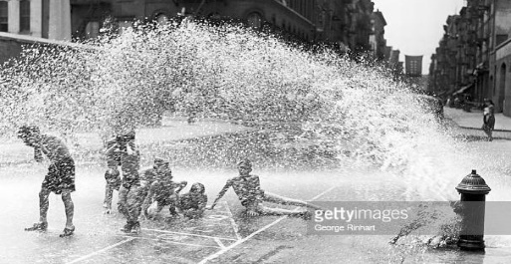
System wide hydrant flushing and valve exercising is tentatively scheduled for the weeks of March 27th and April 3rd. Water Department personnel will begin flushing and valve exercising at approximately 8:30am and stop around 3:00pm daily. You may experience low flow and or cloudy/discolored water during this period. Please let your tap run and the condition should clear up relatively quickly.

Congratulations to Kyle Long who was
voted “Firefighter of the Year” for the The Huron River Fireman’s Association Huron River Joint Fire District. Kyle has will host their annual chicken BBQ on
been a lifelong resident of Monroeville Sunday, April 30th at the fire station
and has 13 years with the Fire Department. located at 155 Monroe St. This will be
Kyle has followed in the footsteps of his a drive thru carry out event beginning
Father and Grandfather as a member of at 11:00am. You won’t want to miss out
The Fire Department. on this delicious meal!

“The creation of a thousand forests is in one acorn.”
– Ralph Waldo Emerson

I am sure you all have noticed the tree removal that has been happening in the Village. This removal is necessary for several reasons. Some trees were lifting the sidewalks and others were in the electric lines. The Village has to trim the trees to keep the lines clear. Every year they have had to trim them and that is a lot of maintenance and cost. Be assured the plan is to replant some trees in those places. The trees that will be planted will be more appropriate in size for the area and in consideration of the lines. There are several small trees that will not grow too high that would be a better selection. As always, if you are interested in having a tree planted in your boulevard, please contact the Village Office. If you would notice a tree in the boulevard that needs some attention please contact the Village Office, too. We do try to walk around and look at the trees for any concerns but we might miss some.

There will be an Arbor Day ceremony which will take place April 22nd at 9:00am. The tree planting will take place at 74 West St. The ceremony helps the Village attain Tree City USA status. The Village is proud to have been a Tree City for over 15 years!!
Shade Tree Commission
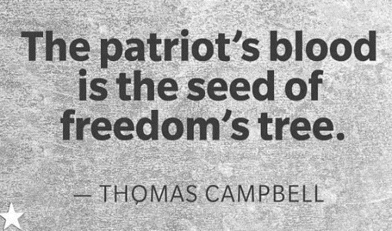
Each year Monroeville ‘s American Legion has faithfully planned for the Village’s Memorial Day service to remember and honor our military personnel who have died. Held in Commons Park, this year the event will be held on Monday, May 29th. Led by our police cruisers, the event starts with a parade from the high school to Commons Park that includes several local groups, decorated bikes and wagons, our own Monroeville High School marching band, and trucks and engines from our Huron River Joint Fire Dept. This event has always drawn a crowd that enjoys music by a wonderful choir and our awesome marching band, a speaker who is selected each year to deliver a meaningful speech, recognition of the fireman and police officer of the year, the laying of the wreath, and raising of the American flag. Please join us on May 29th for this year’s memorable and traditional Memorial Day event. Hope to see you there!

Monroeville Police Staffing & Dept News

The Monroeville Police Department continues to recruit for part time officers. However, like all other departments throughout the country, fewer and fewer people want to become police officers. We will continue our endeavors to attract qualified applicants.

In October, Officer Jordan Hanuscin resigned to go to the Sheffield Village Police Department. In addition, Officer Jordan Eggleston will be leaving for the Elyria Police Department. We wish both officers well on their journey through their law enforcement careers. They will be missed.

A tentative full time job offer has been given to part time officer Jonah Mersereau. Jonah is a Norwalk native and was hired part time in January. Pending successful completion of his required physical, he will be promoted to full time status in the very near future.

Chief Lyons has been promoted to first Vice Chair of the North Central Working Group of the U.S. Department of Justice. The Department of Justice has four working groups. Each group is comprised of 12-16 states. The mission of these working groups is to formulate policies and standards that will eventually be adopted by all criminal justice agencies throughout the United States. Chief Lyons is the law enforcement representative for Ohio.

Officer Nick Meyer recently received his certification as a Domestic Violence Instructor. Congratulations Nick!!

The Monroeville Police Department has become certified through the Ohio Collaborative. The Collaborative is a State of Ohio panel that has established recommended guidelines in areas of use of force, recruitment, and anti-bias enforcement. Each year, the police department will need to recertify to the state to show that the police department is in compliance.
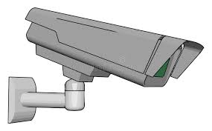

The photo enforcement program continues on with the addition of two cameras that will cover north and southbound traffic on North Street. Placement of the cameras are dictated by the number of citizen complaints and or accident history. As of this writing, photo enforcement cameras are located at the following:

Eastbound at the 300 block of Monroe Street.
North and Southbound on North Street
Westbound on U.S. 20 at the Brooklyn Street intersection
Eastbound and Westbound on U.S. 20 at the State Route 99 intersection
Eastbound and Westbound on U.S. 20 at the Monroe Street intersection

Additionally, mobile speed measuring devices are being carried by the officers on patrol.

The Monroeville Police Department received a second grant award from the Ohio Department of Criminal Justices Services for the purchase of body cameras. The Department currently utilizes recording cameras in the police cruisers. This second grant will enable all full-time officers have their own body camera. The grant award is $3,656.56 and covers the entire cost of the body cameras and accessories.
Chief Gary Lyons and Staff

We are so pleased that Tom Gray, our Village Administrator, has been appointed to serve on four high level American Municipal Power (AMP) Board committees. AMP is a non-profit wholesale power supplier and service provider for 133 member communities in nine states, with Monroeville being one of those communities. Tom will serve as a member of the Fremont Energy Center, the Prairie State Committee, the AMP Transmission Committee, and the Joint Hydro Committee. Monroeville is a participant in all four of these AMP energy sources. As one of only four Ohio non-board committee members, Tom will be attending meetings for these assignments both in-person and virtually. He will be a huge asset to Monroeville as critical power and energy decisions are being made that could have a direct impact on our Village’s electric system. Congratulations Tom!

NEW UTILITY BILL FORMAT COMING SOON!!

IN THE COMING MONTHS YOU WILL SEE A CHANGE TO YOUR UTILITY BILL! THAT’S RIGHT, AFTER 45 YEARS OF SEEING YOUR UTILITY BILL ON A POST CARD WE ARE MAKING THE SWITCH TO AN 8 1/2 X 11 PAPER INVOICE. SIMILAR TO THE ONE YOU SEE HERE.

THIS CHANGE WILL NOT ONLY BE A NEW LOOK BUT WILL ALSO ALLOW FOR ADDITIONAL INFORMATION TO BE INCLUDED ON YOUR UTILITY BILL. INFORMATION SUCH AS YOUR BEGINNING AND ENDING READINGS ALONG WITH YOUR CONSUMPTION. PREVIOUS PAYMENTS, CURRENT AMOUNTS DUE, AND PAST DUE AMOUNTS WILL BE INCLUDED.

ALSO, DISCONNECTION DATES MAY BE LISTED ON THE BILL, WHICH WOULD ELIMINATE THE NEED FOR A SEPARATE MAILING OF SHUT OFF NOTICES. FOR SOME OF YOU THIS WILL BE AN ADJUSTMENT AS YOU WILL NEED TO PAY ATTENTION TO THAT PORTION OF THE INVOICE AND KNOW THAT A SECOND NOTICE WILL NOT BE MAILED.

YOU MAY SEE CHANGES TO THIS NEW FORMAT FROM TIME TO TIME AS WE ADJUST TO THE LAYOUT AND INFORMATION THAT MAY BE ADDED. WE BELIEVE THIS CHANGE WILL BE BENEFICIAL FOR YOU, OUR CUSTOMERS, AND HOPE YOU FIND THEM EASY TO READ AND INFORMATIVE.

*INCOME TAX RETURNS ARE DUE BY TUESDAY, 4/18/2023*

If you owe an income tax balance that accrued prior to 1/1/21, please contact the Village of Monroeville Administrative Office at 419-465-2922 to make payment arrangements.

Here are some helpful tips from the IRS for filing this year’s return:

1. Start Early to Avoid Delays
Even with additional IRS employees working to help taxpayers deal with changing and potentially confusing filing requirements, this year's filing season could still be a tough one. If your return is flagged for review, your refund will almost certainly be delayed.
What can you do to speed things along?
- If your tax return is simple (filed with a single W-2 and the standard deductions), get it done early and e-file. Avoid potential mail delays by setting up direct deposit with the IRS.
- If your tax return is more complex, start gathering your information and engage help ASAP. The sooner you start the process, the more time you'll have to track down missing information, smooth out discrepancies or find a qualified tax professional.

2. File an Accurate Return
Inaccuracies in your tax return are a common trigger for an IRS audit. The IRS checks the information you provide against W-2 forms from your employer; 1099s from clients, banks or investment companies; and payment data from the government itself. If your tax return differs from what the IRS has on file, it may be flagged for a manual review, which could lead to a full-blown audit and possibly delay your refund.
Before you file, check your return for accuracy against the information the IRS has on file. Get a free digital copy of your tax transcript by visiting the IRS' Get Your Tax Record site.

3. Plan for an Extension Now if You Need One
If you can't get your tax information together by the April 18 deadline, you can file an extension to automatically move your deadline to October 16. But don't wait to pay the taxes you owe: The IRS expects you to make a good faith estimate if you want to avoid penalties and interest. Also be mindful of all IRS deadlines this year, including estimated tax payments for 2023.

